The Hard Side of Patenting Software

# INTRODUCTION

The first patent granted by the United States of America was granted to Samuel Hopkins for an improved method for creating pot ash and pearl ash.[1] Today, computers and software reign supreme, creating a global economy heavily dependent on instant communication. The United States Patent and Trademark Office (“USPTO”) recently issued its ten millionth patent.[2] Computers have changed the face of the world, and each year half of the patents issued by the USPTO are related to software.[3] Despite the increasing presence of the computer based technology in life, software patents can be difficult to obtain and defend.[4] In the wake of the *Berkheimer v. HP* decision[5], the USPTO issued the Berkheimer Memo[6], which severely limited how patent examiners reject patent applications for not meeting the requirements for patent eligibility contained and implied by 35 U.S.C. § 101. This change has eased the burden of applicant seeking software patents, however it has created diverging standard between the judicial system, and the USPTO’s standard for approval, which may lead to granting invalid patents. The patent system has too long shoe-horned software patents into an antiquated system designed to encourage innovation of only physical inventions. This note will guide readers through the legislative history and standards regarding software patents, the repercussions of the *Berkheimer* decision, and a possible solution to this patent software dilemma: updating the United States patent system.

# BACKGROUND

The United States Patent System is rooted in the Constitution[7] and first laid out in law by the Patent Act of 1790. The Act dictated that patents be granted by a board composing only three members: the Secretary of State, Secretary of War and Attorney General.[8] Patent law has grown in scope considerably and today is codified in Title 35 of the United States Code as enacted Congress in 1952.[9] Rather than a small board, patent applications are scrutinized by examiners at the USPTO. 35 U.S.C. § 101 states that patents may be obtained for “any new and useful process, machine, manufacture, or composition of matter, or any new and useful improvement thereof”. Despite the inclusiveness of this broad statement, patentability and patent eligibility is limited by both statute and judicial rulings.[10] Patentability describes the standards to receive a patent, requiring a discovery be novel, nonobvious, and the inventor must disclose their invention with detail.[11] Patent eligibility concerns what subject matter warrants the incentives for invention and protections provided by patent law.[12] These two standards are closely related and are often conflated by courts when patent validity is considered.[13] 35 U.S.C. § 101 forms the basis of patent eligibility,[14] and the judiciary holds that it contains an implicit exception disallowing patents for laws of nature, natural phenomena, and abstract ideas.[15] These three exceptions prevent monopolies on foundational laws and concepts that many technologies may depend on, insuring that the limited monopoly provided for by law does not hinder innovation.[16] However too broad an interpretation of these exceptions would also impede the patenting of important discoveries, therefore an invention or discovery cannot be unpatentable merely because it contains natural phenomena or algorithm.[17]

## Patent Eligibility: Laws of Nature, Natural Phenomena, and Abstract Ideas

These three exceptions not always clearly defined or distinct from one another. Laws of nature include well known laws of physics such as gravity or Einstein’s famous “E = mc2”.[18] Natural phenomena include more physical natural occurrences such as plants, minerals, lightning.[19] The exceptions extend to even newly discovered uses of naturally occurring phenomenon.[20] In *Funk Brothers Seed Co. v. Kalo Inoculant Co.* [finish citation], the disputed discovery was a mixture of bacteria for inoculating the seeds of several different types of plants at once, rather than separately.[21] It was ruled to be not eligible for patent and therefore no infringement because the bacteria had not been altered; it was a natural phenomenon.[22] Conversely, in *Diamond v. Chakrabarty*, a new species of bacteria was created that digested oil was upheld to be patentable because it was not naturally occurring and it was unpatentable simply because it was a living organism.[23]The lines are not so clearly drawn regarding abstract ideas.

The Supreme Court has not defined “abstract idea” nor is there a test for discerning its meaning.[24] Each patent must be considered on a case by case basis.[25] Algorithms and mathematical formulas are categorized as abstract ideas, but as laws of nature are frequently captured in formulaic terms, the exceptions often overlap.[26] Patents not ineligible merely because they rely on a law of nature or algorithm,[27] but to be patentable inventors must do than describe the idea or law and append the words “apply it”.[28] Limiting formulas to a particular technological environment will also not make them patentable.[29] However, it is not impossible to receive patents that concern mathematical formulas. Patents must have additional steps outside of the patent ineligible concept that integrate the equation into the process as a whole.[30] They must have an inventive concept outside of the patent ineligible idea.[31]

Two Supreme Court cases personify these differences. In 1972, before the rise of the digital age, the Supreme Court heard arguments regarding a method for converting binary cored decimal to pure binary. In binary encoded decimal (BCD) each digit of a number is represented by a four-digit binary segment e.g. 534 would be represented as 0101-0011-0100, where 0101, 0011, and 0100 are the numbers 5, 3, and 4 respectively in pure binary; in pure binary 534 would be represented as 1000010110.[32] With no definition of abstract ideas, the court begins with comparing the claims with previous cases and facts.[33] However at the time the patentability of computer programs was still in debate, and the patent is held unpatentable because it has no practical exception outside of a digital computer.[34] Clearly the Court did not understand importance digital (the more advanced counter-part to analog) computers would play in the course of the future, and when they dismissed the patent for having no use outside of computers! Although the claims described hardware components which performed this improved algorithm for this important conversion, it was not sufficient to meet the Court’s requirements for patentability. Fast Forward to 1980; the Supreme Court considers claims for a process for curing synthetic rubber. This process relied heavily on a formula known as the Arrhenius equation, and by continually taking temperature measurements, a digital computer was able to use the formula to provide an accurate cure time.[35] Here the Supreme Court stated the claims must be considered as a whole, and that use of a mathematical formula did not disqualify a patent, and upheld the patent. This decision seemly reversed *Benson*, but Supreme Court characterized the invention as a method for curing rubber, rather than a math formula. Examining the claims as a whole, the Court found that they held additional steps that integrated the equation into a process as a whole and therefore patentable. The patent did not seek to protect the formula, but rather the process of how the formula was used.[36] Despite similar dependencies on mathematical formula, two different outcomes occurred, suggesting that physical transformation is required for patent eligibility[37] and how an invention is labelled is critical to a patent surviving scrutiny.

## Software Patents & Abstract ideas

These exceptions cause difficulty in several areas: business methods, bio-technology, methods of medical treatment, and software.[38] Software is not easily sorted into the statutory categories of 35 U.S.C. § 101: it is not a “machine, manufacture, or composition of matter”[39], and must therefore be a “process”. The first three categories are physical and easily patentable providing the invention meets requirements for patentability.[40] Whereas processes are not as tangible and therefore are more difficult to patent.[41] Software as a member of the process category of patents, is similarly difficult to patent for several reasons: 1) it is intangible; 2) software frequently is made up of algorithms; and 3) it can be seen as a mere representation of an abstract idea.[42] Many believe that this eligibility requirement is stifling innovation with its chilling effect on patents.[43] These inherent difficulties require inventors to claim their inventions in specific ways. Early decisions relating to software patents seemed to require physical effects to make the software appear mechanical [44], and more easily fit into the other categories. As previously mentioned, *Diehr* upheld the process for curing rubber, in spite of its reliance on a mathematical formula because of the physical transformation that occurred in the rubber, but invalidated *Benson*’s conversion from BCD to binary.[45]

[discuss the passing of the “machine or transformation test” in Bilski v. Kappos. ]

[Discuss abandoned state street test]

The traditional way to claim software is Beauregard claim.[46] These claims began in response to *In re Beauregard*, which quoted the Commissioner of Patents and Trademarks who stated that software embodied in a tangible medium was patentable.[47] Thus claims often contain a variation on the following, “A computer readable medium containing program instructions…”[48] in an effort to connect the abstract nature of software with something tangible and real.

[explain the meaning of “directed to”] – Enfish

In 2012, the Supreme Court heard a petition concerning processes that help doctors who administer thiopurine drugs determine if a dosage is too low or too high. The improved process relied upon the relationships between the concentration of metabolites in the blood and drug dosage. The Supreme Court held that the process did not transform the natural laws into patent-eligible application. Mayo framework introduced a two step process to determine if an invention claims “building blocks of human ingenuity, which are ineligible for patent protection” or if the patent integrates building blocks into something more. [What was the impact?]

[Fill in details and implications from journal articles]

[alice] In 2014, the patent world was rocked by *Alice Corp. Pty. Ltd. v. CLS Bank Intern*, in which the Supreme Court ruled that escrow software was a patent ineligible invention. The opinion created a two-step framework, based largely on the *Mayo* holding, to determine if an invention was patent eligible. In step one of the framework the Court must determine if the claims at issue are directed to a patent-ineligible concept; if yes then they proceed to step two which asks: “what else is there in the claim before us?”[49] This second step is determining whether additional elements transform the nature of the claim into patent eligible application.[50] The claim elements must be considered individually and in combination.

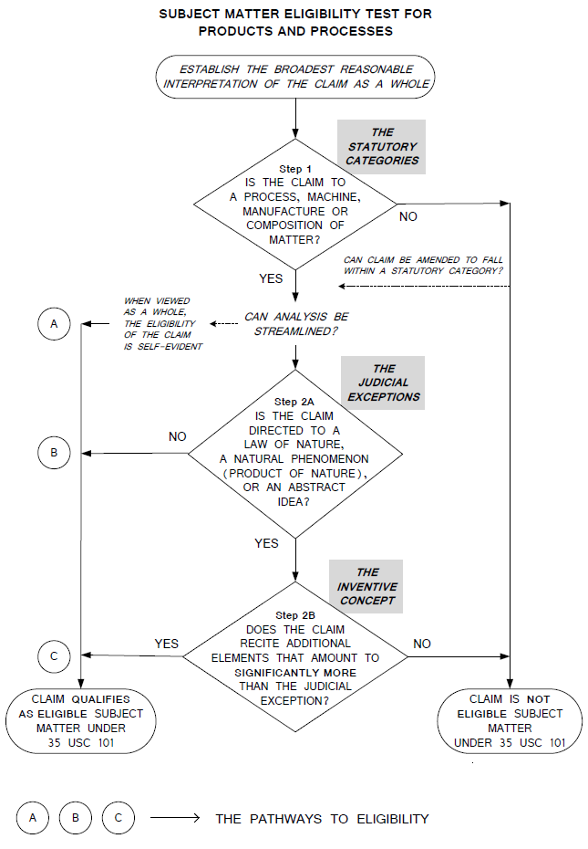

Figure 1 - <https://www.uspto.gov/web/offices/pac/mpep/s2106.html>

Pledge of Honesty

On my honor, I submit this work in good faith and pledge that I have neither given nor received improper aid in its completion.

/s/ Seth Guthrie

1. https://10millionpatents.uspto.gov/
2. https://10millionpatents.uspto.gov/
3. <https://www.ipwatchdog.com/2017/05/21/alice-over-half-u-s-utility-patents-issued-annually-software/id=83367/>; https://www.ificlaims.com/rankings-trends-2017.htm
4. *See e.g.* Benson, Berkheimer
5. Berkheimer
6. How in the world do you cite the Berkheimer memo?
7. U.S. Const. art 1, § 8, cl. 8.
8. P.J. Federico, *Operation of the Patent Act of 1790*, 18 J.Pat.Off.Soc. 237, 238 (1936) (discussing the workings of the Patent Act of 1790).
9. MPEP – INTRODUCTION. <https://www.uspto.gov/web/offices/pac/mpep/mpep-0020-introduction.html>. [HOW TO CITE MPEP?]
10. 35 U.S.C. §§ 102, 103, 112; *Mayo Collaborative Servs. v. Prometheus Labs., Inc.*, 566 U.S. 66, 70, 132 S. Ct. 1289, 1293, (2012).
11. 35 U.S.C. §§ 102, 103, 112
12. CITATION NEEDED
13. CITATION NEEDED
14. CITATION NEEDED
15. *Mayo Collaborative Servs. v. Prometheus Labs., Inc.*, 566 U.S. 66, 70, 132 S. Ct. 1289, 1293, (2012) (restating the long-held exceptions 35 U.S.C. § 101: laws of nature, natural phenomena, and abstract ideas).
16. *Gottschalk v. Benson*, 409 U.S. 63, 67, 93 S. Ct. 253, 34 L.Ed.2d 273 (1972) (holding a method for converting binary-coded-decimals to binary unpatentable)
17. *Mayo Collaborative Servs. v. Prometheus Labs., Inc.*, 566 U.S. 66, 70, 132 S. Ct. 1289, 1293, (2012) (restating the long-held exceptions 35 U.S.C. § 101: laws of nature, natural phenomena, and abstract ideas)
18. Diamond v. Chakrabarty, 447 U.S. 303 on page 309,
19. Diamond v. Chakrabarty, 447 U.S. 303 on page 309,
20. *Funk Bros. Seed Co. v. Kalo Inoculant Co*., 333 U.S. 127, 131, 68 S. Ct. 440, 442, 92 L. Ed. 588 (1948)
21. *Funk Bros. Seed Co. v. Kalo Inoculant Co*., 333 U.S. 127, 131, 68 S. Ct. 440, 442, 92 L. Ed. 588 (1948)
22. *Funk Bros. Seed Co. v. Kalo Inoculant Co*., 333 U.S. 127, 131, 68 S. Ct. 440, 442, 92 L. Ed. 588 (1948)
23. *Diamond v. Chakrabarty*, 447 U.S. 303, 304, 100 S. Ct. 2204, 2205, 65 L. Ed. 2d 144 (1980)
24. [CITATION NEEDED] – Software Patents and Pretrial Dismissal Based on Ineligibility: *41 Simply put, the “abstract idea” doctrine states that an idea cannot be patented.128 However, nothing is as simple as it seems. The Court has long struggled with what makes something “abstract.”129 In fact, they have even appeared to contradict themselves.130 Both Mayo and Alice failed to provide a firm definition of what constitutes an “abstract idea.”; See also Mayo, which does this comparison
25. [CITATION NEEDED] – Software Patents and Pretrial Dismissal Based on Ineligibility: Clarifying the § 101 landscape has not been an easy task. Instead of establishing a firm definition of what constitutes an “abstract idea,” the Federal Circuit has decided cases on a claim-by-claim basis.284

    See Amdocs (Isr.) Ltd. v. Openet Telecomm. Inc., 841 F.3d 1288, 1293-94 (Fed. Cir. 2016).
26. *See Diamond v. Dieher; and* 
27. Diehr
28. Mayo, Quoting Benson
29. In re Bilski
30. Mayo, quoting Diehr
31. Mayo, Quoting Parker v. Flook
32. Gottschalk v. Benson
33. *Gottschalk v. Benson*
34. *Gottschalk v. Benson*
35. *Diamond v. Diehr*
36. *Diamond v. Diehr*
37. *Diamond v. Diehr,* 450 U.S. 175, 184, 101 S. Ct. 1048, 1055, 67 L. Ed. 2d 155 (1981) (noting several times that the respondents claims involve transforming of raw rubber into a different state).
38. CITATION NEEDED
39. 35 U.S.C. § 101
40. Randall Rader, Benjamin Christoff, Patent Law in a Nutshell 56 (3rd ed. 2018).
41. *See e.g.* [Alice, Mayo, Berkheimer, etc.]; *see* Kathleen Chapman, Esq. & Stephen Ball, Esq*., Challenges with Patenting Software,* Vt. B.J., Winter 2007/2008, at 36
42. CITATIONS NEEDED
43. Paul R. Gugliuzza, Quick Decisions in Patent Cases, 106 Geo. L.J. 619, 622 (2018)
44. Kathleen Chapman, Esq. & Stephen Ball, Esq., Challenges with Patenting Software, Vt. B.J., Winter 2007/2008, at 36, 37
45. *Diamond v. Diehr*; *Gottschalk v. Benson*
46. Intellectual Property Channeling for Digital Works; Preserving The Value Of Medical Device Patents During The Rise Of Three-Dimensional Printing – Westlaw Journal IP 2013 WL 5808127, at *4
47. *In re Beauregard*, 53 F.3d 1583, 1584 (Fed. Cir. 1995)
48. *See e.g.* *CyberSource Corp. v. Retail Decisions, Inc.*, 654 F.3d 1366, 1373 (Fed. Cir. 2011); *SEVEN Networks, LLC v. Google LLC*, No. 2:17-CV-441-JRG, 2018 WL 5263271, at *30 (E.D. Tex. Oct. 23, 2018)
49. *Alice Corp. Pty. Ltd. v. CLS Bank Intern*
50. *Alice Corp. Pty. Ltd. v. CLS Bank Intern*